Subject: Important Logistics & Travel Information for SA3CC and the Vera Rubin NET Meetings in La Serena, Chile
Dear SA3CC and Vera Rubin NET In-Person Attendees,
If you're traveling to La Serena, Chile for the SA3CC and Vera Rubin NET meetings, please review the logistics guide below to ensure a smooth trip.

Stay Connected: WhatsApp Group
We’ve created a WhatsApp group, "2025 SA3CC Meeting," to share real-time updates and announcements. Feel free to join for important meeting details (and maybe a joke or two!, and photos).

Flight Transfers in Santiago, Chile
You will need to change terminals at the Santiago International Airport (from International to Domestic). Instructions on how to navigate this transfer can be found here.

Airport Pickups in La Serena
Please provide your arrival and departure details in this form:
SA3CC Travel Details Form. If you can, please see if other participants are arriving with you on the same flight, and to consider sharing a taxi/Uber to the hotel.
If you need additional logistics information, we can schedule a Zoom Q&A session with Ranpal Gill (Rubin/NOIRLab). Let us know if this would be helpful!
The La Serena airport has free wifi.
Taxi: Just outside the baggage claim area, you'll find the following counter, where the official taxi counter is located. To find a taxi, exit through either of the two airport gates, where you'll find the first row of cars, where taxis park. These can be identified by their orange license plates. The rates according to the official webpage of the airport, should be around 10 to 12 USD for taxis, and 6 USD for ride share transfer.
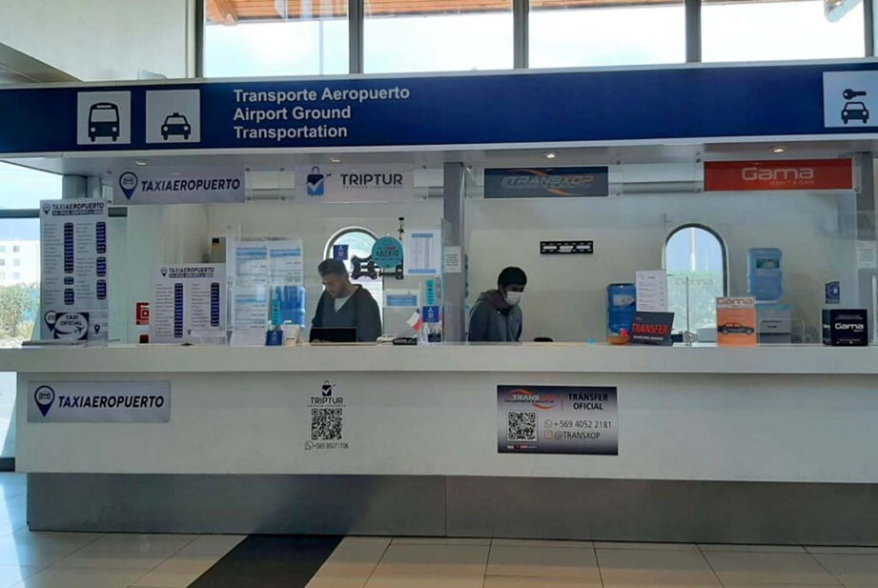
Uber/Ride Share: If you choose to take an Uber, you'll be picked up from the second row of cars shown in the image.
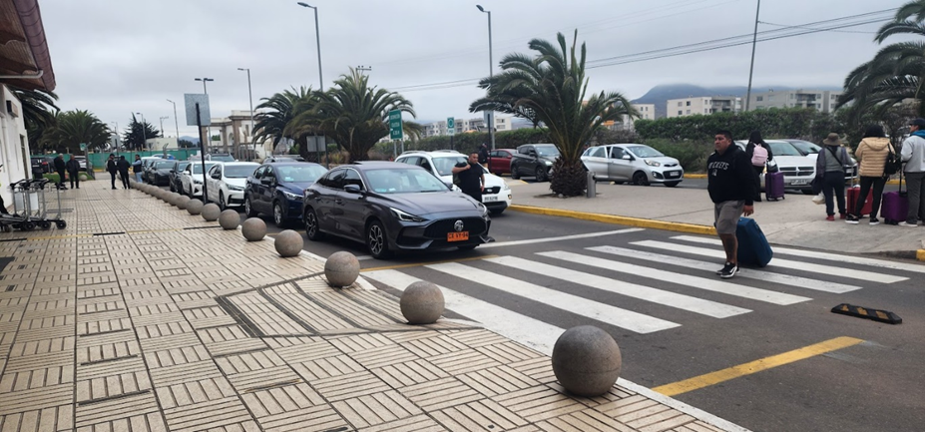

Conference Hotel
Club La Serena Hotel, Av. del Mar 1000, 1710249 Coquimbo, La Serena, Chile
Website: https://clublaserena.com/
The hotel is providing a breakfast.
Direction: https://maps.app.goo.gl/XG5pE8YJXVqDDXf3A
Hotel Block Code: REUNA25
Valid when booking from today
Dates of stay: From 03 May 2025 to 12 May 2025
https://direct-book.com/properties/hotelclublaserenadirect?locale=es&items[0][adults]=2&items[0][children]=0&items[0][infants]=0&currency=USD&checkInDate=2025-05-03&checkOutDate=2025-05-12&trackPage=yes&promocode=REUNA25
*Note: If you choose to stay elsewhere, please be aware that you will need to come to La Serena Club Hotel each day (Tuesday to Friday) to catch the bus for the meeting or arrange your own transportation to the AURA Recinto

Vera Rubin Observatory Visit & daily access to the AURA Recinto (location of the meetings)
To visit the Vera Rubin Observatory summit or for daily access to the AURA Recinto, please follow these steps:
📌 Complete the Required Safety Training:
AURA/Vera Rubin Observatory Safety Training Video
📌 Submit the Safety Training Form:
Safety Training Completion Form
Access type: Visita Corporativa de Base Facility y Montaña / Base Facility and Mountain Corporate Visit
Full name of Staff member: Ranpal Gill - rgill@lsst.org
Wear sturdy flat soled shoes, and warm clothes. It’s cold at the Summit and in the observatory.
🚍 Observatory Visit Schedule:
- Pickup Location: Club La Serena Hotel, Av. del Mar 1000, 1710249 Coquimbo, La Serena, Chile
- Departure Time: Monday, May 5th, 9:00 AM CT
- Lunch at the Summit

SA3CC Meeting Logistics

Breakfast: The Club La Serena Hotel includes breakfast with your stay. Please have breakfast before the shuttle transfer to the Recinto. Breakfast will not be served at the meeting.
🚍 Daily Transport to the Meeting Venue
- Pickup Time & Location: 8:00 AM from Club La Serena Hotel
- Meeting Venue: AURA Recinto, 1500 Ave Juan Cisternas, La Serena
🚍 Transport Back to the Hotel
- Pickup Time & Location: 5:00 PM from the AURA Recinto

Social Dinner
- 19:30 – 21:30 Restaurant TBD.
- Transport to/from the restaurant will be arranged.
- If you're bringing a guest, please note that their meal will need to be paid for separately at the venue.

Departure Logistics: Transport to La Serena Airport
✅ Self-arranged transport

Recommended Nearby Attractions
If you have extra time, here are some great places to explore in and around La Serena:
🌿 Humboldt Penguin Reserve – Book a tour to see wildlife
🌎 Parque Nacional Fray Jorge – UNESCO Biosphere Reserve
🔭 Mamalluca Observatory – A stunning tourist observatory
🍸 Pisco Elqui – Visit charming villages and pisco distilleries
- Los Nichos
- Doña Josefa
- Pisquera ABA
🔗 About La Serena, Chile
🔗 Top Attractions in La Serena
🔗 Restaurants in La Serena
If you have any questions, feel free to reach out. Looking forward to seeing you all in La Serena!
Best regards,
The 2025 SA3CC program committee

